CS 518 Quantum Networking and Security, Spring 2024

*Homework – 2*

***(Read Sections 1.5 (1.5.1, 1.5.2), 1.6, and 4.4 to 4.7- Parag Lala; all materials covered in the lectures)***

1. Write two paragraphs on Quantum Networking (Quantum Internet) based on lectures

Ans:

Quantum network often reffered to as the quantum internet, uses the principles of quantum mechanics to facilitate communication. Classical network relies on classical bits for data transmission, whereas qubits are used for data transfer in the quantum network. Quantum communication is the exchange of quantum states over a distance,

generally requiring the support of substantial classical communication. A key feature of quantum networking is quantum entanglement, a phenomenon where the state of one particle is directly related to the state of another, no matter the distance between them. This allows for the creation of quantum links known as entanglement channels, enabling instantaneous and inherently secure communication over long distances, a concept known as quantum teleportation.

Only quantum states moves; the electron or other physical device remains where it was, and the  
receiver can in fact be a very different form of the physical device than the sender. Quantum networks bring new capabilities to  
communication systems. Quantum physical effects  
can be used to detect eavesdropping, to improve the  
share sensitivity of separated astronomical  
instruments or to create distributed states that will  
enable numerical quantum computation over a  
distance using teleportation. Quantum networks could enable distributed quantum computing, where quantum computers at different locations collaborate to solve complex problems more efficiently than classical computers. Additionally, they could significantly improve the sensitivity and resolution of sensor networks, with applications ranging from deep space exploration to medical diagnostics.

1. Describe the nature of superposition with the Mach-Zehnder Interferometer device (based on class lecture 2 and any online resources/papers) (no more than two paragraphs)

Watch this video on Mach-Zehnder Interferometer:

<https://www.google.com/url?sa=t&rct=j&q=&esrc=s&source=web&cd=&cad=rja&uact=8&ved=2ahUKEwijr-XDz--DAxVumGoFHa7JCwUQFnoECA8QAw&url=https%3A%2F%2Feightify.app%2Fsummary%2Fmathematics-and-science%2Funderstanding-superposition-mach-zehnder-interferometer%23%3A~%3Atext%3DThe%2520beam%2520splitter%2520in%2520a%2Cone%2520photon%2520interfering%2520with%2520another.&usg=AOvVaw2FvTwXuSypVh-eQLWpx8YU&opi=89978449>

Ans:

The Mach-Zehnder Interferometer exemplifies the peculiar nature of superposition in quantum mechanics, a stark contrast to classical physics where the total electric field is merely the sum of individual fields. This device, comprising a beam splitter, mirrors, and detectors, ingeniously demonstrates the wave-particle duality inherent in photons. Through its design, the Mach-Zehnder Interferometer creates an environment where interference patterns can be observed, revealing the dual nature of light as both a wave and a particle. This interference is a result of the superposition principle, where each photon can exist in multiple states simultaneously. In the context of this device, a single photon can traverse both paths created by the beam splitter, leading to interference effects. The ability to manipulate this interference, directing light entirely to one detector or splitting it between two, showcases the versatility and ingenuity of this experimental setup.

Superposition in the Mach-Zehnder Interferometer challenges classical concepts of measurement and outcome. Unlike classical physics, where measurement results in an average or intermediate state, quantum superposition yields discrete outcomes, defying intuition. In this quantum realm, each photon interferes with itself, allowing it to be in both beams simultaneously, leading to probabilistic outcomes. The probability of finding the photon in a certain direction after measurement is determined by the square of the coefficient, reflecting the wave-like nature of superposition. This aspect underscores the interconnectedness of states, wave functions, and vectors in quantum mechanics. Consequently, to comprehend the state of the system fully, multiple measurements are necessary. These measurements are not merely a means of averaging outcomes but are essential to assess the probabilities and reconstruct the quantum state, as the results are not intermediate but distinct and probabilistic in nature. This reveals a profound difference in how outcomes are determined in quantum mechanics compared to classical physics.

1. a) Qubit is a two-state quantum system - explain based on class lecture on Mach-Zehnder Interferometer; b) write general formula for QM (Quantum Mechanics) superposition of photon on upper beam and photon on lower beam

Ans:

Quantum system which has two distinct state is called “Qubit”, they are the building blocks of quantum computer

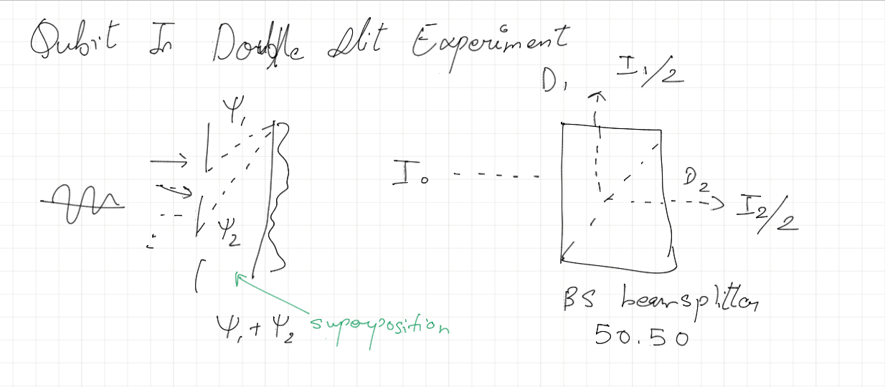This concept is vividly illustrated in the context of the Mach-Zehnder Interferometer, a device used to demonstrate quantum mechanical phenomena. In this setup, a photon, which can be considered a qubit, is split by a beam splitter into two paths: an upper beam and a lower beam. the photon exists in a superposition of being in both the upper and lower beams simultaneously. This superposition is a direct manifestation of the two-state quantum system that a qubit represents. When the paths recombine, the photon interferes with itself, showcasing its dual existence in both states until a measurement is made, at which point the superposition collapses to a single state.

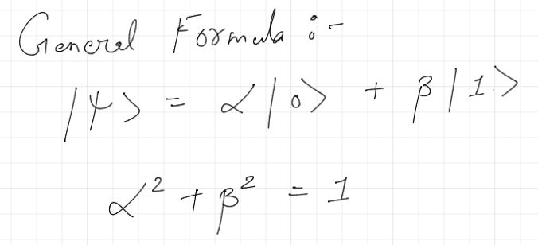

1. How a classical computer is physically realized and how quantum computer can physically be realized (not more than a paragraph).

Ans:

A classical computer is physically realized through electronic components, primarily transistors, which serve as switches to represent binary states (0s and 1s). These transistors are integrated into microchips to form logic gates and memory units, enabling the execution of complex computations. The fundamental operation of a classical computer involves manipulating these binary states through electrical signals to perform arithmetic and logical operations. In contrast, a quantum computer is realized through the use of qubits, which can be physically implemented using a variety of quantum systems such as superconducting circuits, trapped ions, or photons. These qubits exploit quantum mechanical properties like superposition and entanglement to represent and manipulate information in ways that are fundamentally different from classical computers. Quantum computers require precise control and measurement of quantum states, often at extremely low temperatures to minimize decoherence, and they hold the potential to solve certain types of problems much more efficiently than classical computers.

1. Describe the arrangement of **a single** 50/50 BS (Beam Splitter) that takes input, basis state |0> or basis state |1> and creates Superposition.

Ans:

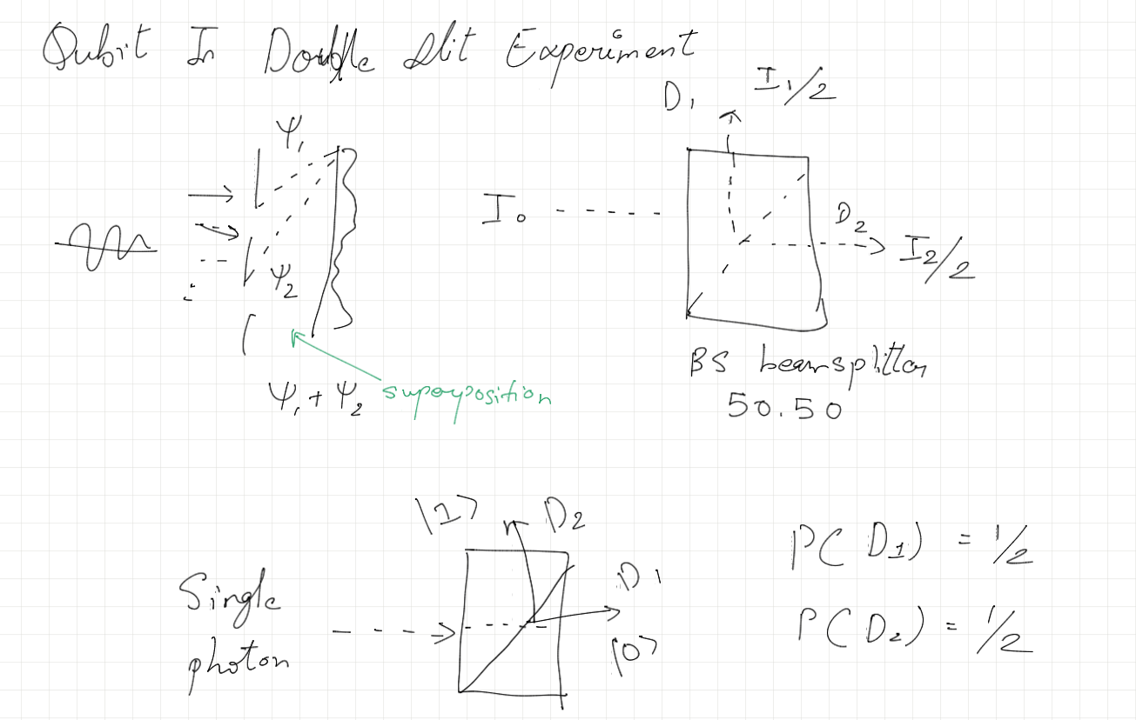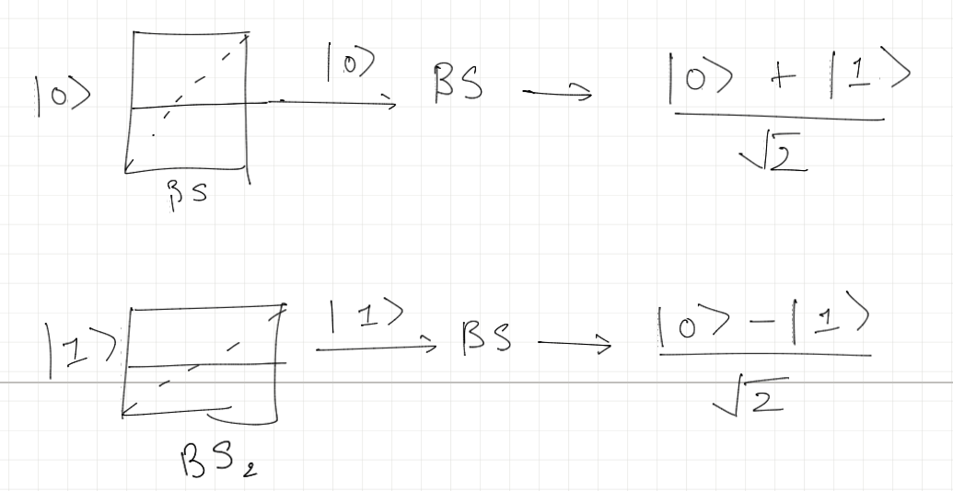

1. Assume an arrangement (or a Device) with three Beam Splitters, BS1, BS2, BS3, and a BS creates Superposition 𝟏/√𝟐 (|**0> +|1>),** when |0> comes in as an input; and creates 𝟏 /√𝟐 (|**0> -|1>)** when |1> comes as an input.

**A:**

1. Write the output of the first BS, BS1, when input is |0>   
   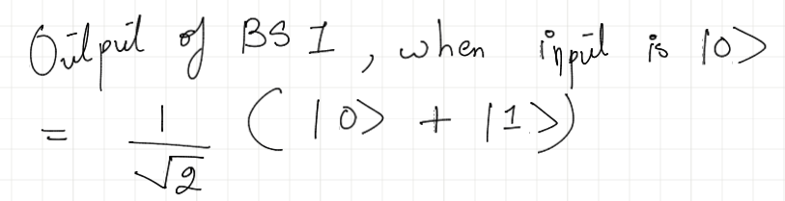ANS:

1. Write the out output of the second BS (BS2), when the output of the BS1 (in a) is fed to the BS2.   
   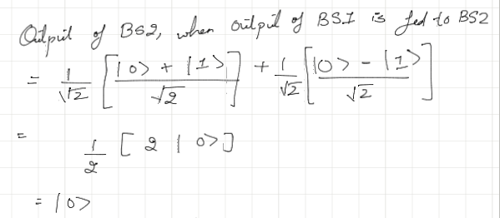ANS:
2. Write the output of the third BS (BS3), when the output of the BS2 (in a) is fed to the BS3.   
     
     
   Since the input to BS3 is |0>, as per the output of BS2  
     
   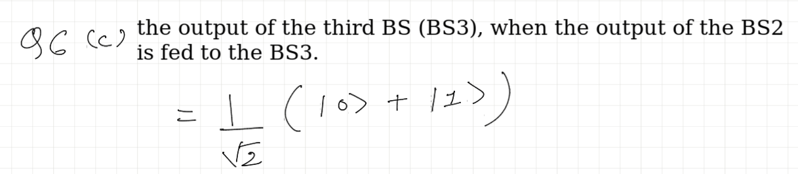
3. Give your observations and analysis based on a, b, and c.

The sequence of beam splitters is effectively altering the state of the photon in a predictable way.

* After the first beam splitter, the photon is in a superposition of being in both states |0> and |1>.
* The second beam splitter, interestingly, results in the photon being found only in the |0> state, despite the superposition input. This is due to the interference of the amplitudes for the |1> state, which cancel each other out.
* The third beam splitter again puts the photon into a superposition state, the same as after the first beam splitter.

**Q6 B:**

1. Write the output of the first BS, BS1, when input is |1>

Ans:

𝟏 /√𝟐 (|**0> -|1>)**

1. Write the out output of the second BS, BS2, when the output of the BS1 (in a) is fed to the BS2.

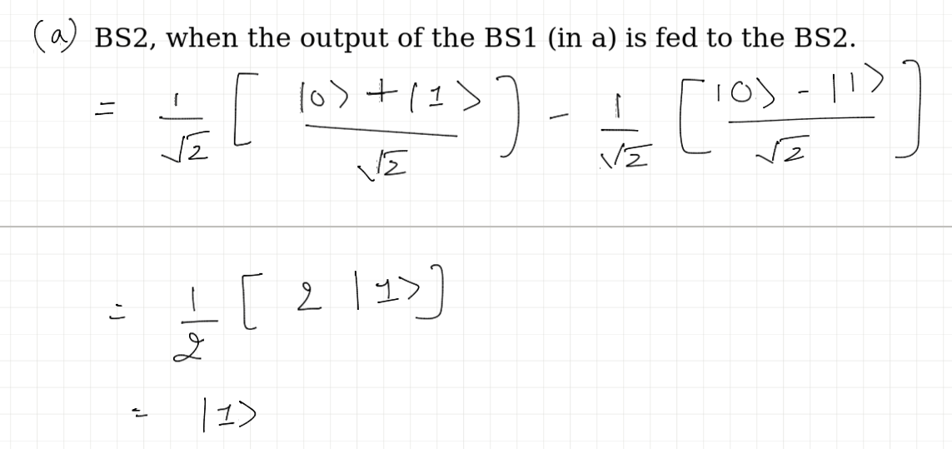Ans:

1. Write the out output of the third BS, BS3, when the output of the BS2 (in a) is fed to the BS3.

Since the input to BS3 is |1>, as per the output of BS2

1. Give your observations and analysis on a, b, and c.

Ans:

1) The output of the first beam splitter (BS1) with input |1> is a

superposition 𝟏 /√𝟐 (|**0> -|1>)** ; demonstrating the creation of quantum superposition from a definite state.

2) The output of the second beam splitter (BS2), fed with the output of BS1 (when input is |1>), simplifies to just |1>, indicating a constructive interference that favors the |1> state.

3) The output of the third beam splitter (BS3), fed with the output of BS2 (when input is |1>), is 𝟏 /√𝟐 (|**0> -|1>)**  reinstating the superposition state with a phase difference, similar to the output of BS1.

1. A) Describe Dirac notation (in a few sentences); b) Show that Bras are useful in calculating probability amplitude (page 10, last paragraph of Parag Lala); (that is if a general state of Qubit is **|ψ> = α|0> + β|1>, the probability of a Qubit being in a state |1> can be determined by combining the general Qubit and the bra <1|- <1||ψ> = <1|ψ> = ?**

a) Dirac notation, often used in quantum mechanics, is a compact and expressive way to represent states and operations in quantum systems. It comprises two main elements: "bras" and "kets". A "ket", written as ∣ψ⟩, represents a state vector in a Hilbert space. Conversely, a "bra", written as ⟨ϕ∣, represents the dual vector, or the complex conjugate transpose, of the state vector. Together, they can form inner products (bra-ket or bracket, giving the notation its name) and outer products, useful for expressing quantum states, probabilities, and operators.

b) Calculating Probability Amplitude Using Bras:

Let's consider the general state of a qubit ∣ψ⟩=α∣0⟩+β∣1⟩. To find the probability amplitude of the qubit being in the state ∣1⟩, we use the bra ⟨1∣. The inner product ⟨1∣ψ⟩ gives us the amplitude of the qubit being in the state ∣1⟩. Mathematically, this is calculated as follows:

⟨1∣ψ⟩=⟨1∣(α∣0⟩+β∣1⟩)

Since the states ∣0⟩ and ∣1⟩ are orthogonal (i.e., ⟨0∣1⟩=0 and ⟨1∣0⟩=0), the inner product of ⟨1∣0⟩ vanishes, and we are left with:

⟨1∣ψ⟩=α⟨1∣0⟩+β⟨1∣1⟩=β

1. If the state of a qubit is defined by **|ψ> = α|0> + β|1>** and note that this is a linear combination (10 Points)

of ket |0> and ket |1>;  
α and β are the probability amplitude of 0 and 1 respectively;  
and |α|2 + |β|2 = 1.  
If the input of a device (BS) is |1>, find the probability of the |ψ> will overlap with |1> that is the inner product of |0> and |ψ> (i.e., <0| ψ> ).

To find the probability of the state ∣ψ⟩ overlapping with the state ∣1⟩, we actually need to calculate the inner product ⟨0∣ψ⟩, as per your request. This seems a bit contradictory since you're asking about the overlap with ∣1⟩ but then requesting the inner product with ∣0⟩. Let's clarify both scenarios:

1. Overlap with ∣1⟩:
   * The overlap of ∣ψ⟩ with ∣1⟩ is given by ⟨1∣ψ⟩.
   * For ∣ψ⟩=α∣0⟩+β∣1⟩, this becomes ⟨1∣(α∣0⟩+β∣1⟩), which equals β since ⟨1∣0⟩=0 and ⟨1∣1⟩=1.
   * The probability of ∣ψ⟩ being in the state ∣1⟩ is ∣β∣2.
2. Overlap with ∣0⟩ (as you've asked):
   * The overlap of ∣ψ⟩ with ∣0⟩ is given by ⟨0∣ψ⟩.
   * Substituting ∣ψ⟩ with its definition, we get ⟨0∣(α∣0⟩+β∣1⟩).
   * This simplifies to α⟨0∣0⟩+β⟨0∣1⟩=α⋅1+β⋅0=α.
   * The probability of ∣ψ⟩ being in the state ∣0⟩ is ∣α∣2.

1. What is the uniqueness of quantum computer (class notes and Parag Lala) (150 words) (5 points)

Quantum computers utilize the principles of quantum mechanics, notably superposition and entanglement, to process information. Unlike classical bits, quantum bits (qubits) can exist in multiple states simultaneously (superposition), allowing quantum computers to perform many calculations at once. Additionally, entanglement enables qubits to be correlated in ways that are impossible in classical systems, significantly enhancing computational power for certain tasks. It combines superposition and entanglement allows quantum computers to solve specific complex problems much faster than traditional computers.

Unlike classical bits that are either 0 or 1, quantum bits (qubits) can exist in multiple states simultaneously due to superposition. This allows quantum computers to perform many calculations at once, potentially solving certain complex problems much faster than classical computers. Entanglement, another quantum phenomenon, enables qubits that are entangled to be correlated in ways that classical bits cannot, providing a significant boost in computational power for certain tasks.